Poll Topic | Plastic bags and their impact on the Omani environment
Posted Date | 10 July 2018
The Ministry carried out a survey on its "Twitter" social network about the use of plastic bags in markets and commercial centers and replacing them with biodegradable or reusable bags.

Objectives: This poll aims to raise the level of awareness of the danger of using plastic bags on the Omani environment, humans and wildlife. It also aims to measure the level of awareness in this aspect.

Target: Pioneers and followers of the "Twitter" social network channel.

Participants: 4,514 individuals participated in the poll by direct voting in the ministry's Twitter account, while the tweet was linked to the ministry's website.

Survey duration: 3 days Poll

Result: 89% of the respondents voted in favor of banning plastic bags, while 11% voted against the ban.

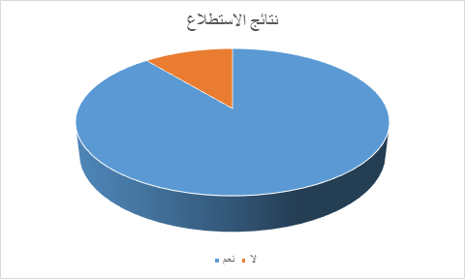
Participations & Proposals: More than 130 individual participated in proposals and comments related to the danger of plastic bags to the Sultanate, human, wildlife and trees, as well as their impact on marine life, beaches, coral reefs, etc., and these proposals will be followed up by the concerned department.

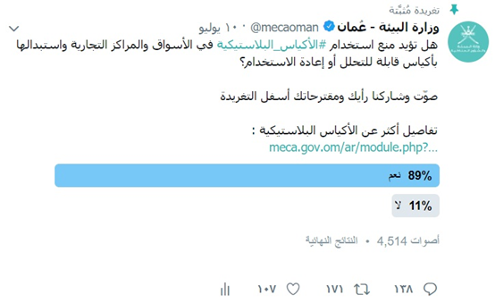

Accompanying information: The poll included information about plastic bags, their components, harms and the Sultanate’s efforts in this regard.

Plastic Bags and Its Impact on Omani Environment
Plastic bags are made of thermoplastic materials commonly extracted from petroleum raw materials called polymers and other chemicals. Most plastic bags are made of high concentrated polyethylene, which is transparent by nature. Other chemicals are added to many targets, such as colors that give plastic bags different colors, and other chemicals for thickness, transparency, frostiness and bendability.
Danger of Plastic Bags
A plastic bag has vast risks on the environment as it takes hundreds of years till it decompose which leads to environmental and health hazards. Plastic is classified as one of the 20 most dangerous products. It is considered to be one of the most dangerous materials during manufacturing. It is also light in weight with constant use and due to the length of time it takes to decompose, this leads to contamination of vast areas in various cities and beaches. Furthermore it flies with ease that makes a difficult task in collection and disposal in addition distorting the public appearance. Its presence on the beaches holds great threat to marine environment and a serious threat to lives of turtles, dolphins and other living organisms.
The Sultanate's Efforts to Limit Use of Plastic Bags
There is a pressing need for change in the Sultanate in current situation due to dependence in use of plastic bags of all kinds which is distributed widely in the various shops all over the Sultanate. Although its noted use biodegradable plastic bags in some shops, in addition to the existence of alternative paper use in some of shops. There are challenges that exist in terms of individual consumption patterns and the need to raise awareness level in all segments of society, and that what Ministry of Environment and Climate Affairs and partners from various governmental and private are working on.
The ministry's efforts included field visits to plastic bag factories in various Sultanate Governorates to learn about manufacturing methods and nature of the materials involved in the production of plastic bags, as well as the implementation of some field visits to the neighbor countries in order to view the integrated system of registration and controls and regulation related to plastic bags.
The preparation of biodegradable plastic bags specifications and having manufacture controls and application requires several procedures, especially those relating to registration and inspection. Therefore specialists met from the Ministry with several plastic bags manufacturers and had presented a visual presentation about plastic bags and their disadvantages and options, including the use of materials to accelerate decomposition with a record time as well approaches in use of recycling methods and the replacement of plastic bags with paper or cloth, and the adoption of Gulf standards for biodegradable plastic bags with oxygen.
The Ministry of Environment has also carried out awareness lectures in schools and associations as well as campaigns to clean the beaches and diving with the participation of various society segments, in order to raise awareness of danger of excessive use of plastic bags. This included several companies such Oman Oil Company's, Oman Oil Refineries and Petroleum Industries Company (ORPIC), the Environment Society of Oman and other governmental and private bodies, associations and civil society institutions. As well Ministry's participation in the initiative of clean seas with the UNEP Regional Office to clean up coral reefs and a number of coastal sites to mitigate the effects of all kinds of waste.

Competition for the best environmental initiative to reduce plastic pollution

